APPENDIX 1

COURSE RECOMMENDATION BASED ON INTEREST

END TERM REPORT

By:

Name | Roll No. | Reg No. | Section
Varun Aditya | 4 | 11802502 | K18SJ
Aman Rajpoot | 6 | 11802448 | K18SJ
Ashish Chaubey | 8 | 11802482 | K18SJ
Himansu Sharma | 21 | 11802456 | K18SJ



Department of Intelligent Systems School of Computer Science Engineering Lovely Professional University, Jalandhar

2019-20

APPENDIX 2

STUDENT DECLARATION

This is to declare that this report has been written by us. No part of the report is copied from other
sources. All information included from other sources have been duly acknowledged. We aver that if any part of the report is found to be copied, we shall take full responsibility for it.

Varun Aditya
Roll number:4

Aman Rajpoot Roll number: 6

Ashish Chaubey Roll number: 8

Himansu Sharma
Roll number: 21

Date: 13/04/2020

APPENDIX 3

TABLE OF CONTENTS

TITLE PAGE NO.
- Bonafide certificate………………………………………………….……4
- Background and objectives 5 - 6
- Description of Project 6 - 7
- Description of Work Distribution…………………………………………8
- Implementation of project 8 - 11
- Technologies and Frameworks Used 12
- SWOT Analysis 12

APPENDIX 4

BONAFIDE CERTIFICATE

Certified that this project report “MOVIE REVIEW SENTIMENT ANALYSIS” is the bonafide work of “Varun Aditya, Aman Rajpoot, Ashish Chaubey, Himansu Sharma” who carried out the project work under my supervision.

Dipen Saini (Assistant Professor) ID: 23681

Department of Intelligent Systems

BACKGROUND AND OBJECTIVES

BACKGROUND

There are several courses available on internet nowadays. The main purpose of this project is to recommend the courses which are most suitable for the user based on their interest. It happens most of the time that when we see a lot of courses available on internet, we get confused that which one to choose from those large variety of courses. This project proposes the use of various forms of machine learning techniques to develop a course recommendation system which can guide the user as per the rating provided by him/her and the other users for different courses that they are interested in. This will help them to choose the most appropriate course for themselves.

MOTIVATION

This project is being done as a part of our academic studies in the field of Artificial Intelligence. Being aspirants of a job in the field of machine learning, a program for course recommendation gives us the perfect opportunity to start working in our field of interest. By creating a model that can recommend course based on the user’s interest also creates an opportunity for many aspirants to work on similar kind of projects. Most importantly the project gives us the time to learn and understand where our true interest lies and where we stand with respect to it.
CONCRETE GOALS AND OUTCOME

The main objective of this project is to design a system to help the user to make the appropriate choice by recommending them the courses based on their interest. So, if we can offer them a
better way to simplify their course selection process based on ratings provided by them and other users in their previous courses then it will save their time and will reduce their efforts so that they can learn more and more and also help others by rating the studied courses.

DESCRIPTION OF PROJECT

Module Description
    - Data extraction module: what tis module does is that, it converts our dataset (mixture of strings, special characters and integers) e.g. {DBMS:5, ML:5, big data:3, AI:0}. To integer formats i.e. [5,5,3,0]. And then it will save this extracted data into a csv file for further processing.
    - Data visualization module: what this module does is that it helps us to visualize our data. By providing various means of visualization. Here this module will show the intensity of various ratings. In laymen terms this module will plot our data in the form of number of users vs rating.
    - Similarity module: this module is used to find the correlation between individual pairs of data. This takes our training data as input and then normalizes the data. After normalizing the data it compute the correlation between each pair of data using pearson correlation method. At last it save the correlation of each data pair into a csv file (“similarity_matrix.csv”)
    - Pearson module: This module simply calculates pearson correlation coefficient between 2 vectors.
    - Rating prediction module: This module is the heart of our project. What is does are the following things:
5.1. it first takes the data set and the similarity matrix
5.2. then for each (user, course) it predicts the unknown rating, by clubbing the global baseline approach and collaborative filtering approach.
6. Main module: this module is simply the connector to the front-end and back-end. This module take cares of all the GUI and the connection between the front and back-end.
7. efficiency-check module: this module checks the ROOT MEAN SQUARE ERROR in our prediction

- DESCRIPTION OF WORK DIVISION

Name | Roll no. | Reg No. | Modules
Varun Aditya | 4 | 11802502 | 5,7
Aman Rajpoot | 6 | 11802448 | 3,4
Ashish Chaubey | 8 | 11802482 | 1,2
Himansu Sharma | 21 | 11802456 | 6

IMPLEMENTATION OF PROJECT

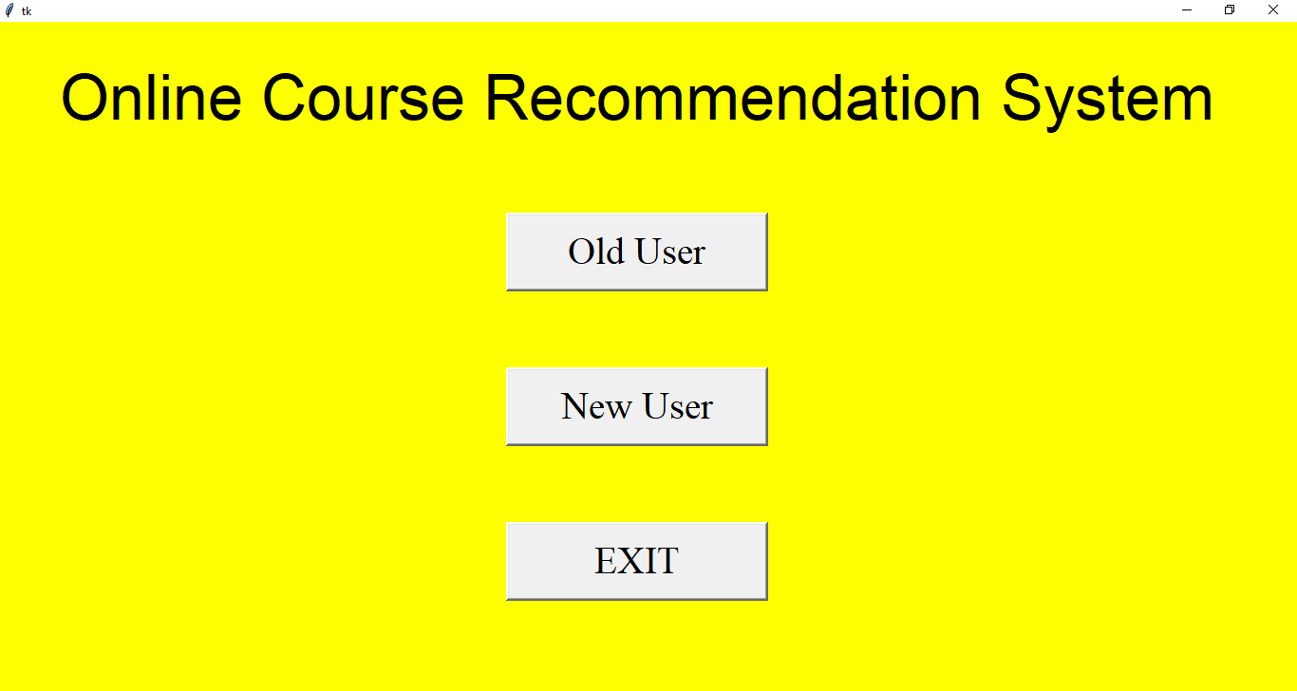
- Home Page of the ONLINE COURSE RECOMMENDATION SYSTEM. In this page there are 3 buttons.
- Old user: if the user was already having an account, then they can click this button for login. To get recommendation based on their interest.
- New user: if the user is new then they can click here, to get recommendation based on most popular courses.
- EXIT: this is to exit from the system.
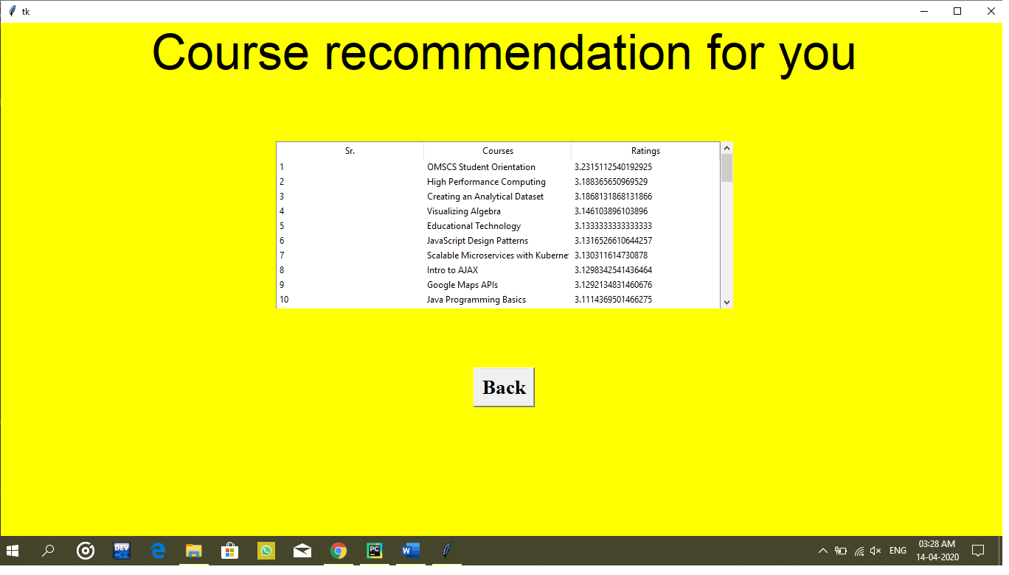
- Now when you will click “NEW USER” then you will be directed here. These are the most popular course on our system.

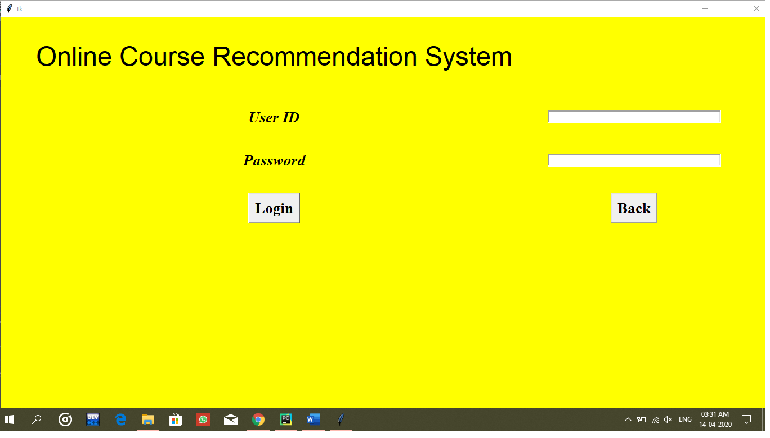
- When you will click old user you will be directed to this page for log-in.
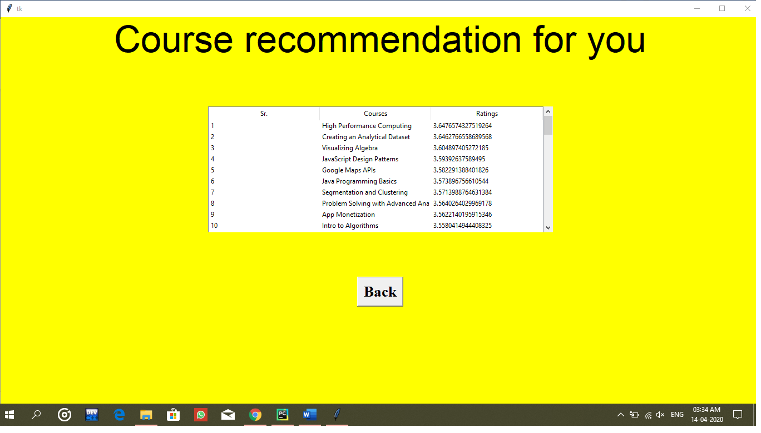
- After login you will get recommendation based on your interest

- TECHNOLOGIES AND FRAMEWORK USED
Dataset used: user-course rating data
Technologies used in Backend: Python
Technologies used in Frontend: Python
IDE used: pycharm

SWOT ANALYSIS
Strengths: This recommendation system uses both mixture of global baseline approach and collaborative filtering approach. To give a very good prediction. Also, it solve the problem of cold start (only for users)
Weaknesses: As the dataset is to sparse in nature, that is why sometime it may give slightly more deviated answer. Sometime error in prediction may be more.
Opportunities: We can collect data from the many users giving reviews at the website and create our own dataset to train the classifier time to time.
Threats: At present this recommendation system is static (i.e. all the precomputation has been already done and saved). So, it will not adapt to the user change.

